**AIM: An effective webpage on food product theme.**

**OBJECTIVE: To showcase current menus for foods and drinks that will tempt potential customers to order from or visit your business with the help of mouth-watering pictures and attractive descriptions. The purpose of a restaurant website is to help customers choose you over other eateries.**

**CODE:**

**<!DOCTYPE html>**

**<html lang="end">**

**<head>**

**<meta charset="UTF-8">**

**<meta name="viewport" content="width=device-width, initial-scale=1.0">**

**<title>Food Wedsite</title>**

**<link rel="stylesheet" href="style.css">**

**<link rel="stylesheet" href="https://cdnjs.cloudflare.com/ajax/libs/font-awesome/6.4.2/css/all.min.css" integrity="sha512-z3gLpd7yknf1YoNbCzqRKc4qyor8gaKU1qmn+CShxbuBusANI9QpRohGBreCFkKxLhei6S9CQXFEbbKuqLg0DA==" crossorigin="anonymous" referrerpolicy="no-referrer" />**

**</head>**

**<body>**

**<section>**

**<nav>**

**<ul>**

**<li>Home</li>**

**<li>About</li>**

**<li>Menu</li>**

**<li>Landing</li>**

**<li>Team</li>**

**<li>Contact</li>**

**</ul>**

**</nav>**

**<div class="text">**

**<p class="word">NEW RESTAURANT</p>**

**<h1><span>Welcome</span> to<br> The world of<br> Tasty & Fresh Food.</h1>**

**<p class="textarea">The restaurant's interior design embraces the concept of biophilic architecture, creating a space that fosters a deep connection with nature. Wooden accents, living walls, and earthy tones create a warm and inviting atmosphere, while soft acoustic music sets the mood for a leisurely dining experience. Whether you're enjoying a romantic dinner for two or gathering with friends and family, Gaia's Garden provides the perfect backdrop for memorable moments.**

**</p>**

**<div class="search_bar">**

**<i class="fa-solid fa-magnifying-glass"></i>**

**<input type="text" placeholder="Search">**

**<button>Search</button>**

**</div>**

**</div>**

**</section>**

**<div class="second">**

**<div class="img_box">**

**<div class="img_card">**

**<div class="display_text">**

**<p>FOOD SOURCHING</p>**

**</div>**

**<img src="images/1.jpg">**

**</div>**

**<div class="img_card">**

**<div class="display_text">**

**<p>MENU DEVELOPMENT</p>**

**</div>**

**<img src="images/2.jpg">**

**</div>**

**<div class="img_card">**

**<div class="display_text">**

**<p>RESTAURANT</p>**

**</div>**

**<img src="images/3.jpg">**

**</div>**

**</div>**

**</div>**

**<div class="description_1">**

**<div class="d_text">**

**<h1>950/-</h1>**

**<p class="head_title">BEEF WITH GINGER</p>**

**<p class="desc">**

**Indulge your senses in a symphony of flavors with our Ginger Glazed Beef Stir-Fry, a tantalizing dish that marries the rich, savory notes of tender beef with the zesty warmth of fresh ginger. Each bite is a culinary delight, offering a perfect balance of textures and tastes that will leave you craving more.**

**The magic begins as our skilled chefs expertly stir-fry the beef and vegetables in a blazing hot wok, locking in their natural juices and preserving their crispness. With a deft hand, they toss in the freshly grated ginger, allowing its aromatic essence to permeate the dish and elevate its taste to new heights. Finally, the ginger glaze is drizzled over the sizzling ingredients, caramelizing to perfection and creating a glossy finish that tantalizes the senses.**

**Served piping hot over a bed of fluffy jasmine rice or silky noodles, our Ginger Glazed Beef Stir-Fry is a feast for both the eyes and the palate. Garnished with a sprinkle of sesame seeds and fresh cilantro, each plate is a work of art that promises to delight even the most discerning of diners. Pair it with a glass of crisp white wine or a refreshing ginger-infused cocktail for a truly unforgettable dining experience.**

**</p>**

**<a href="#" class="dis_btn">READ MORE</a>**

**</div>**

**<div class="dis_img">**

**<img src="images/img_1.jpg">**

**</div>**

**</div>**

**<div class="menu">**

**<h1>Our Menu</h1>**

**<div class="m_box">**

**<div class="m_cards">**

**<div class="m_img">**

**<img src="images/pizza.jpg">**

**</div>**

**<h6>PIZZA</h6>**

**<a href="#" class="m_btn">READ MORE</a>**

**</div>**

**<div class="m_cards">**

**<div class="m_img">**

**<img src="images/salads.jpg">**

**</div>**

**<h6>SALADS</h6>**

**<a href="#" class="m_btn">READ MORE</a>**

**</div>**

**</div>**

**<div class="m_box">**

**<div class="m_cards">**

**<div class="m_img">**

**<img src="images/desert.jpg">**

**</div>**

**<h6>DESSERT</h6>**

**<a href="#" class="m_btn">READ MORE</a>**

**</div>**

**<div class="m_cards">**

**<div class="m_img">**

**<img src="images/drinks.jpeg">**

**</div>**

**<h6>DRINKS</h6>**

**<a href="#" class="m_btn">READ MORE</a>**

**</div>**

**</div>**

**</div>**

**<div class="banner">**

**<div class="b_text">**

**<h6>OUR RESTAURANT</h6>**

**<h1>A new way to experience food</h1>**

**<p>**

**farm-to-table dining, sourcing the freshest organic ingredients directly from local farmers and producers. Our menu is a symphony of flavors inspired by seasonal bounty, offering a contemporary twist on classic dishes from around the world. From vibrant salads bursting with color to hearty mains showcasing the best of land and sea, each plate is a testament to our commitment to sustainability and taste.**

**</p>**

**<a href="#" class="b_btn">READ MORE</a>**

**</div>**

**<img src="images/banner.jpg">**

**</div>**

**<div class="contact">**

**<div class="subscribe">**

**<h1>SUBSCRIBE</h1>**

**<p class="title">to the newsletters and content update</p>**

**<div class="c_search">**

**<input type="text" placeholder="Enter a valid email address">**

**<button>SUBMIT</button>**

**</div>**

**<div class="address">**

**<div class="place">**

**<h3>LOCATION</h3>**

**<p>Kerala 670009</p>**

**<p>India</p>**

**</div>**

**<div class="follow">**

**<h3>FOLLOW US</h3>**

**<div class="icon">**

**<i class="fa-brands fa-facebook-f"></i>**

**<i class="fa-brands fa-twitter"></i>**

**<i class="fa-brands fa-instagram"></i>**

**<i class="fa-brands fa-google-plus-g"></i>**

**</div>**

**</div>**

**</div>**

**</div>**

**</div>**

**<p class="end">Design By<span><i class="fa-solid fa-face-grin"></i>**

**Team 9</span></p>**

**</body>**

**</html>**

**RESULT :**

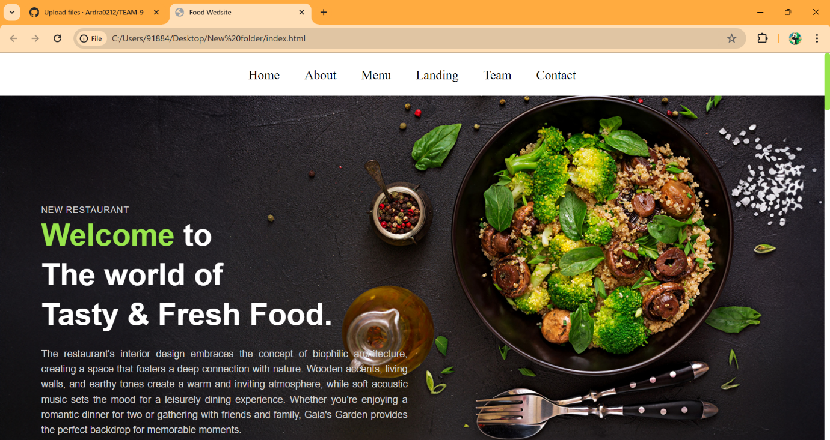

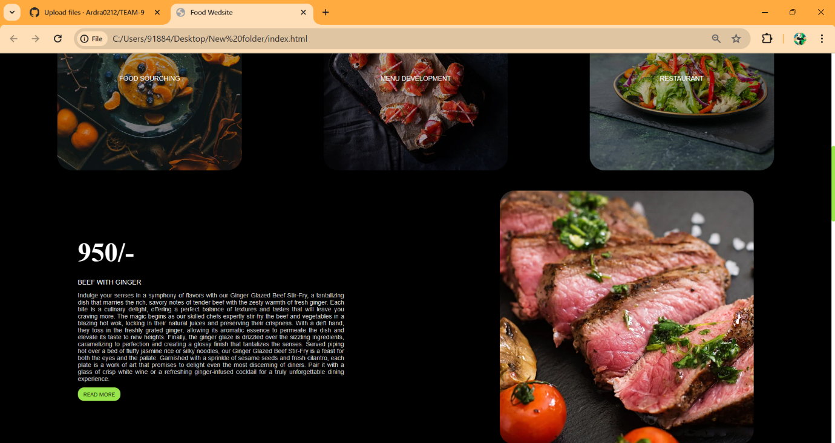

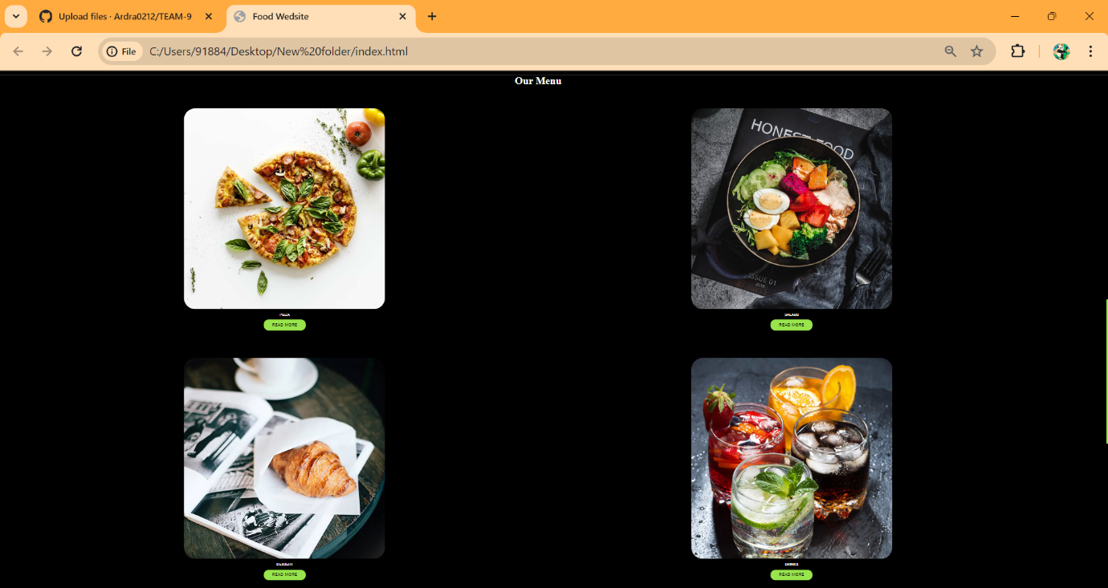

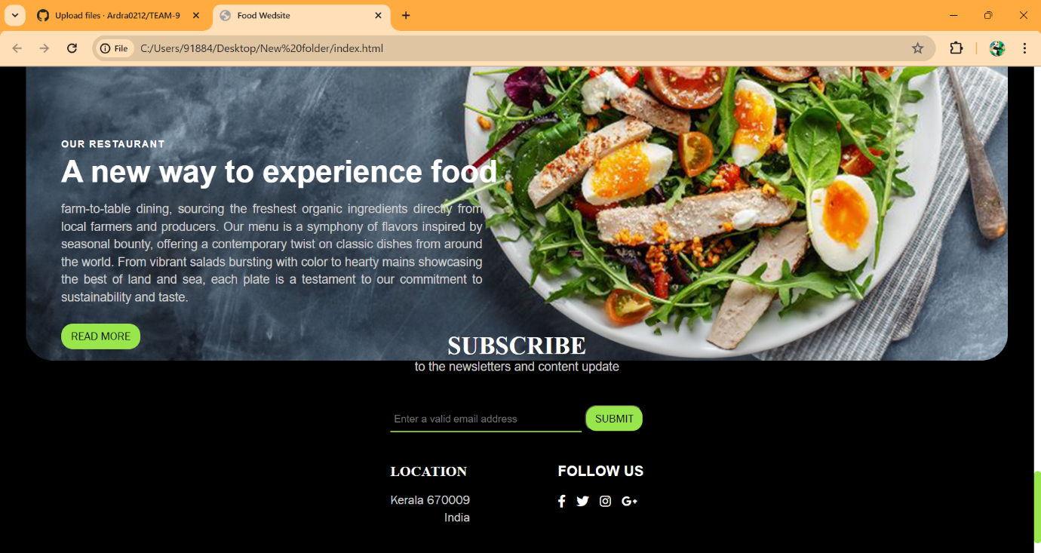

**CONTRIBUTION :**

* **CSCF 001(41) : Half of the style.css was contributed by him.**
* **CSCF 002(42) : Remaining style.css was contributed by him.**
* **CSCF 004(44) : Half of the html part was done by her.**
* **CSCF 005(45) : Rest of the html code where designed by her.**

**CONCLUSION:**

**Along with live practical implementation , We came across various ways to implement the html tags in different ways, also helping us to understand the concept to html tags/elements and CSS better .**